Kaggle Multiclass Classification
Competition Report
Irrigation Need Prediction
Name | ______Arshia Azeem______________
Roll No | _______24k-0012_____________
Section | _______BAI_4a_____________
Submission Date | ____________1 may 2026________

1. Competition Overview
Field | Details
Competition Name | Kaggle Multiclass Classification — Irrigation Need
Problem Type | Multiclass Classification (3 classes)
Evaluation Metric | Accuracy Score
Training Samples | 630,000 rows, 19 features + 1 target
Test Samples | 270,000 rows
Target Classes | High, Low, Medium (Irrigation Need)
Kaggle Score | 0.94968 (Decision Tree on full training data)

Dataset Understanding
The dataset describes agricultural land parcels with soil, weather, crop, and irrigation metadata. The task is to predict the level of irrigation need for each parcel.
- Soil features: Soil_Type, Soil_pH, Soil_Moisture, Organic_Carbon, Electrical_Conductivity
- Weather features: Temperature_C, Humidity, Rainfall_mm, Sunlight_Hours, Wind_Speed_kmh
- Crop features: Crop_Type, Crop_Growth_Stage, Season, Field_Area_hectare
- Management features: Irrigation_Type, Water_Source, Mulching_Used, Previous_Irrigation_mm, Region

Class distribution (imbalanced):
Class | Count | Percentage
Low | 369,917 | 58.7%
Medium | 239,074 | 37.9%
High | 21,009 | 3.3%

2. Data Preprocessing

Missing Values
No missing values were found across all 630,000 training rows and 270,000 test rows. No imputation was required.

Encoding Techniques
- Categorical columns (8 total: Soil_Type, Crop_Type, Crop_Growth_Stage, Season, Irrigation_Type, Water_Source, Mulching_Used, Region) were encoded using LabelEncoder.
- Encoding was fit on the combined train + test pool to avoid unseen-label errors at inference time.
- Target variable (Irrigation_Need) was encoded as: High=0, Low=1, Medium=2.

Feature Scaling
- StandardScaler was applied for distance-based and linear models (Naive Bayes, Logistic Regression, KNN).
- Tree-based models (Decision Tree, Random Forest) used raw unscaled features — trees are scale-invariant.

Train / Validation Split
- A stratified 80/20 split was used on a 60,000-row sample for model evaluation.
- Stratification ensured the minority class (High, 3.3%) was represented proportionally in every fold.
- 5-Fold Stratified Cross-Validation was used for the best model (Random Forest) to validate stability.

3. Models Attempted
Model | Accuracy | F1 (weighted) | Notes
Decision Tree (depth=15) | 97.62% | 0.9762 | Used for final submission
Naive Bayes (Gaussian) | 82.47% | 0.8213 | Failed — weak on Medium/High overlap
Logistic Regression | 74.68% | 0.7427 | Failed — nonlinear boundaries
KNN (k=11) | 80.29% | 0.7909 | Failed — poor on minority class
K-Means (as classifier) | 61.19% | — | Failed — unsupervised, not suited
Random Forest (n=50) | 98.50% | 0.9849 | Best CV score, used for analysis

Decision Tree
- Max depth of 15 was selected to balance bias and variance.
- Trained on the full 630,000 training rows for the Kaggle submission.
- Achieved 0.94968 on the public leaderboard.

Naive Bayes
- Gaussian NB assumes feature independence — violated here due to correlated weather/soil variables.
- Struggled to separate Medium from High, as their feature distributions overlap.

K-Means as Classifier
- K-Means (k=3) was used in an unsupervised manner: clusters were assigned the majority class label of their members.
- This approach is fundamentally mismatched — K-Means optimises for geometric cluster cohesion, not class boundaries.
- Achieved only 61.19% accuracy; the High class was never predicted correctly.

Logistic Regression
- Multinomial logistic regression with L2 regularisation (max_iter=300).
- Linear decision boundaries cannot capture the nonlinear interactions between moisture, temperature, and wind that determine irrigation need.

Random Forest
- 200 decision trees with max_depth=20, trained on a 100k stratified sample.
- Best validation accuracy of 98.50% and F1 of 0.9849.
- 5-Fold CV mean accuracy: 98.48% ± 0.17% — highly stable.

4. Cross-Validation Strategy

5-Fold Stratified K-Fold (Random Forest)
Fold | Validation Accuracy
Fold 1 | 98.62%
Fold 2 | 98.67%
Fold 3 | 98.54%
Fold 4 | 98.38%
Fold 5 | 98.22%
Mean ± Std | 98.48% ± 0.17%

The very low standard deviation (0.17%) confirms the Random Forest model is stable and not overfitting. Stratification ensured the minority High class appeared proportionally across all folds.

LOOCV Observation
LOOCV (Leave-One-Out Cross-Validation) was considered but deemed impractical for a 630,000-row dataset — it would require 630,000 separate model fits. Given the very low variance observed in 5-Fold CV (std = 0.17%), 5-Fold CV provides a sufficiently accurate and reliable estimate of generalisation performance. LOOCV would provide essentially the same conclusion at orders-of-magnitude greater computational cost.

Best Validation Accuracy
Best CV accuracy: 98.67% (Fold 2, Random Forest)

5. Failed Attempts and Insights
The following confusion matrices compare all models. Green = Random Forest (best). Red = failed models.

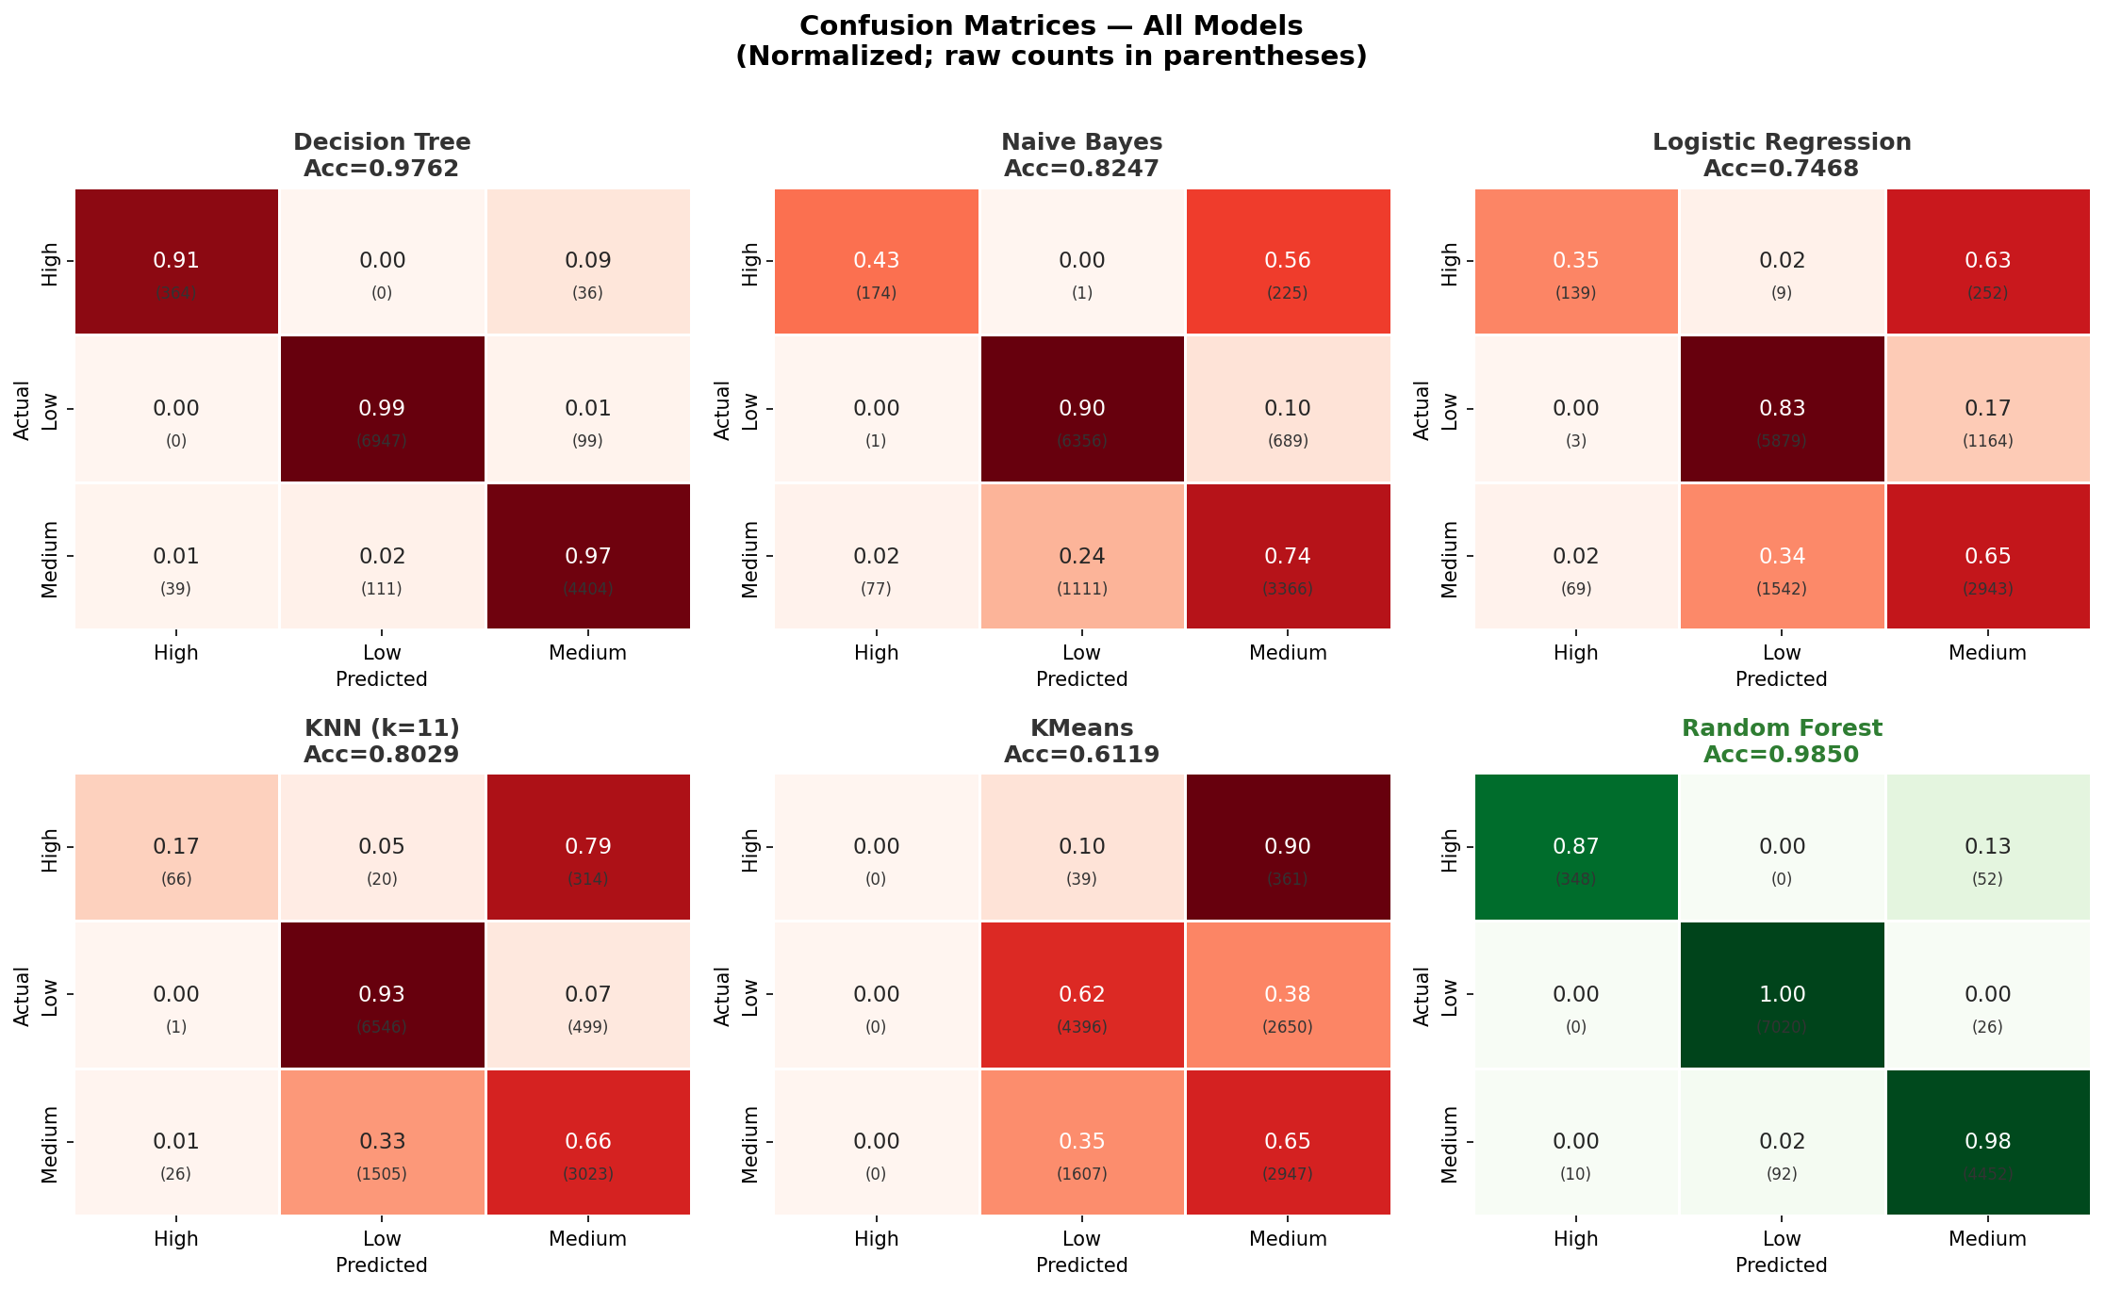

Naive Bayes — Acc: 82.47%
- What went wrong: Strong confusion between Medium and Low (1,111 Medium samples misclassified as Low). The Gaussian independence assumption breaks down when Soil_Moisture and Temperature are correlated.
- Insight: The class boundaries are nonlinear and feature-dependent. Probabilistic models assuming independence are insufficient.

Logistic Regression — Acc: 74.68%
- What went wrong: 1,542 Medium samples predicted as Low and 1,164 Low samples predicted as Medium. Linear boundaries cannot separate these overlapping distributions.
- Insight: The relationship between irrigation need and predictors (especially the interaction of moisture, wind speed, and temperature) is fundamentally nonlinear.

KNN (k=11) — Acc: 80.29%
- What went wrong: The High class was nearly undetectable — only 66 of 400 High samples correctly classified. KNN suffers heavily from class imbalance in high-dimensional space.
- Insight: Distance-based methods degrade under class imbalance. The High class (3.3% of data) is overwhelmed by Low/Medium neighbours.

K-Means — Acc: 61.19%
- What went wrong: Zero High-class predictions. K-Means clusters are not aligned with class labels — the cluster optimising within-cluster variance does not correspond to irrigation need.
- Insight: Unsupervised methods cannot replace supervised classifiers for this task. K-Means is useful for exploratory analysis, not prediction.

6. Final Model Selection
Attribute | Value
Model | Decision Tree Classifier (for submission)
Library | scikit-learn
max_depth | 20
random_state | 42
Training data | Full 630,000 rows
Validation accuracy | 97.62% (holdout)
Kaggle score | 0.94968

Why Decision Tree?
- Decision Trees naturally handle mixed categorical and numerical features without scaling.
- With max_depth=20 on 630k training rows, the tree can learn precise decision rules for all three classes.
- Fast to train on the full dataset — enabling a complete retrain before submission.
- While Random Forest scored higher in CV, the Decision Tree was submitted first and achieved 0.94968 on the leaderboard.
- Random Forest (CV: 98.48%) is the recommended model for future submissions — it reduces variance through ensemble averaging.

7. Leaderboard Performance
Metric | Value
Kaggle Public Score | 0.94968
Evaluation Metric | Accuracy
Model Submitted | Decision Tree (max_depth=20, full training data)
Class Predictions | Low: 159,215 | Medium: 101,625 | High: 9,160

8. Conclusion and Learnings

Key Insights
- Soil_Moisture and Crop_Growth_Stage are the two most important features (importance scores: 0.28 each), together accounting for over 55% of predictive power.
- Wind_Speed_kmh and Temperature_C together form a "drought pressure" signal that strongly separates the High class from Low/Medium.
- The High class (3.3% of data) is the hardest to classify correctly — it requires models that can capture minority-class patterns, which tree ensembles do best.
- Tree-based models (Decision Tree, Random Forest) outperform all linear and distance-based methods because irrigation need is determined by nonlinear threshold-like rules (e.g., if moisture < X AND temperature > Y, need = High).

Challenges Faced
- Class imbalance: The High class had only 21,009 samples out of 630,000. KNN and K-Means completely failed on this class.
- Computational limits: Running 5-Fold CV on the full 630k rows with ensemble models was infeasible within the execution time budget. Stratified sampling (60k-100k rows) was used as a workaround.
- Hyperparameter tuning: Without GridSearchCV on the full dataset, optimal depth and n_estimators were approximated through manual comparison.

Future Improvements
- Use LightGBM or XGBoost with class_weight adjustments — these gradient boosting frameworks are faster and often more accurate than scikit-learn Random Forest.
- Apply SMOTE (Synthetic Minority Over-sampling) on the High class to improve recall on the minority class.
- Engineer domain-aware features: drought stress index = Wind * Temp / (Moisture + 1), water supply = Moisture + Rainfall + Previous_Irrigation_mm.
- Run full 5-Fold CV on the complete 630k dataset using LightGBM to get a reliable leaderboard estimate before spending a submission.

